Spatio-temporal variation of microplastic pollution in the sediment from the Chukchi Sea over five years

Chao Fangª, Yusheng Zhangª, Ronghui Zhengª, Fukun Hongª, Min Zhangª, Ran Zhangª, Jianfeng Mouª, Jingli Mu^{b}, Longshan Lin^{a,}*, Jun Bo^{a,}*
ª Laboratory of Marine Biology and Ecology, Third Institute of Oceanography, Ministry of Natural Resources, Xiamen, 361102, China
^{b} Fujian Key Laboratory of Functional Marine Sensing Materials, Institute of Oceanography, Minjiang University, Fuzhou 350108, China

* Corresponding author
E-mail addresses: bojun@tio.org.cn (J. Bo); linlsh@tio.org.cn (LS. Lin)

Table S1 Detailed location coordinates and MP abundance for every sampling site.
Regions | Sampling data | Stations | Longitude (°E) | Latitude (°N) | Water depth (m) | MP abundance (items kg⁻¹)
Chukchi Plateau | 2016-08-03 | P11 | -165.93 | 78.48 | 526 | 30.55
Chukchi Plateau | 2016-08-21 | R17 | -169.14 | 78.02 | 698 | 86.29
Chukchi Plateau | 2016-08-22 | R16 | -168.96 | 77.08 | 1893 | 9.74
Chukchi Plateau | 2016-07-29 | P23 | -161.23 | 76.32 | 2089 | 41.74
Chukchi Plateau | 2016-08-23 | R13 | -169.10 | 75.45 | 267 | NDª
Chukchi Plateau | 2018-08-10 | P11 | -165.84 | 78.65 | 650 | 14.49
Chukchi Plateau | 2018-08-06 | P22 | -163.69 | 76.58 | 594 | 68.43
Chukchi Plateau | 2018-08-04 | M05 | -172.04 | 76.38 | 2293 | 51.92
Chukchi Plateau | 2020-08-11 | P3-7 | -165.91 | 78.61 | 607 | 110.62
Chukchi Plateau | 2020-08-06 | P2-4 | -165.97 | 76.87 | 915 | 23.44
Chukchi Plateau | 2020-08-02 | R2 | -169.92 | 75.61 | 222 | 138.57
Chukchi Plateau | 2020-08-03 | P1-6 | -166.62 | 75.44 | 288 | 145.55
Chukchi Shelf | 2016-08-23 | R12 | -168.89 | 74.68 | 183 | 27.10
Chukchi Shelf | 2016-08-24 | R11 | -168.88 | 73.80 | 155 | 88.68
Chukchi Shelf | 2016-08-31 | S12 | -160.15 | 72.80 | 65 | 76.99
Chukchi Shelf | 2016-08-31 | S11 | -161.49 | 72.44 | 45 | 37.45
Chukchi Shelf | 2016-08-31 | C23 | -162.71 | 72.03 | 36 | 8.66
Chukchi Shelf | 2016-08-31 | C24 | -160.83 | 71.81 | 45 | 141.57
Chukchi Shelf | 2016-09-01 | C22 | -164.88 | 72.33 | 47 | 60.22
Chukchi Shelf | 2016-09-01 | C21 | -166.77 | 72.60 | 52 | 102.72
Chukchi Shelf | 2016-09-01 | R10 | -168.80 | 72.84 | 61 | 20.75
Chukchi Shelf | 2016-09-01 | R09 | -168.74 | 72.00 | 50 | 47.62
Chukchi Shelf | 2016-09-02 | R08 | -168.89 | 71.18 | 48 | 109.71
Chukchi Shelf | 2016-09-02 | C11 | -168.23 | 69.35 | 51 | 26.28
Chukchi Shelf | 2016-09-03 | CC04 | -167.22 | 68.11 | 50 | 31.80
Chukchi Shelf | 2016-09-03 | R04 | -168.88 | 68.20 | 56 | 39.47
Chukchi Shelf | 2016-09-03 | CC2 | -168.01 | 67.78 | 52 | ND
Chukchi Shelf | 2016-09-04 | R03 | -168.87 | 67.53 | 50 | ND
Chukchi Shelf | 2018-08-02 | R12 | -168.97 | 74.61 | 189 | 37.76
Chukchi Shelf | 2018-09-05 | C24 | -161.54 | 71.70 | 38 | 22.05
Chukchi Shelf | 2018-09-06 | R05 | -168.83 | 68.81 | 47 | 4.60
Chukchi Shelf | 2018-09-07 | CC1 | -168.60 | 67.60 | 42 | 13.29
Chukchi Shelf | 2018-09-07 | CC3 | -167.81 | 67.90 | 53 | 3.88
Chukchi Shelf | 2018-09-04 | C22 | -165.00 | 72.35 | 49 | 42.18
Chukchi Shelf | 2020-08-02 | R1 | -169.14 | 74.64 | 200 | 95.47
Chukchi Shelf | 2020-08-03 | Z3 | -167.16 | 74.33 | 318 | 54.26
Chukchi Shelf | 2020-09-10 | Z4 | -166.61 | 73.54 | 103 | 17.17
ª ND means not detected.

Table S2 MP abundances in the sediments at the same stations from the Chukchi Plateau and Chukchi Shelf over the three voyages.
Regions | Stations | Years | Abundance of fibers related to fishing gear (items kg⁻¹) | Abundance of fibers related to textiles (items kg⁻¹) | Abundance of MPs related to engineering and industry (items kg⁻¹) | Total MP abundances  (items kg⁻¹)
Chukchi Plateau | P11 | 2016 | NDª | 20.05 | ND | 30.55
Chukchi Plateau | P11 | 2018 | ND | 14.49 | ND | 14.49
Chukchi Plateau | P3-7 | 2020 | 110.62 | 55.31 | ND | 110.62
Chukchi Shelf | R12 | 2016 | 9.32 | 17.78 | ND | 27.10
Chukchi Shelf | R12 | 2018 | 37.76 | 37.76 | ND | 37.76
Chukchi Shelf | R1 | 2020 | ND | 29.83 | 110.62 | 95.47
ª ND means not detected.

Table S3 Arctic sea ice indices in the months over the three voyages.
Years | Months | Arctic sea ice extent  (million km²) | Arctic sea ice concentration  (million km²) | Arctic sea ice anomalies (million km²) | The decrease rate constant of Arctic sea ice extent (million km² month⁻¹) | The decrease rate constant of Arctic sea ice concentration (million km² month⁻¹)
2016 | March | 14.4 | 12.5 | 1 | -0.55 | -0.53
2016 | April | 13.7 | 11.9 | 0.9 | -0.55 | -0.53
2016 | May | 11.9 | 10.2 | 1.3 | -0.55 | -0.53
2016 | June | 10.4 | 8.1 | 1.4 | -0.55 | -0.53
2016 | July | 7.9 | 5.3 | 1.4 | -0.55 | -0.53
2016 | August | 5.4 | 3.3 | 1.6 | -0.55 | -0.53
2016 | September | 4.5 | 2.9 | 1.6 | -0.55 | -0.53
2018 | March | 14.3 | 12.7 | 0.9 | -0.56 | -0.54
2018 | April | 13.7 | 12.3 | 0.7 | -0.56 | -0.54
2018 | May | 12.2 | 10.8 | 0.8 | -0.56 | -0.54
2018 | June | 10.8 | 8.8 | 0.8 | -0.56 | -0.54
2018 | July | 8.3 | 5.8 | 1.1 | -0.56 | -0.54
2018 | August | 5.6 | 3.9 | 1.2 | -0.56 | -0.54
2018 | September | 4.8 | 3.4 | 1.4 | -0.56 | -0.54
2020 | March | 14.8 | 13 | 0.6 | -0.50 | -0.50
2020 | April | 13.7 | 12 | 0.9 | -0.50 | -0.50
2020 | May | 12.4 | 10.5 | 1.1 | -0.50 | -0.50
2020 | June | 10.6 | 8.4 | 1.2 | -0.50 | -0.50
2020 | July | 7.3 | 5.1 | 1.8 | -0.50 | -0.50
2020 | August | 5.1 | 3.1 | 1.9 | -0.50 | -0.50
2020 | September | 3.9 | 2.8 | 1.9 | -0.50 | -0.50
Data were extracted from the National Snow & Ice Data Center (https://nsidc.org/data/seaice_index/bist)

Table S4 Correlations between the MP abundances and Arctic sea ice indices.
Sea ice indexes  Correlations ª | Regions | Abundances of fibers related to fishing gear (items kg⁻¹) | Abundances of fibers related to textiles (items kg⁻¹) | Abundances of MPs related to engineering and industry (items kg⁻¹) | Total MP abundances  (items kg⁻¹)
The decrease rate constant of Arctic sea ice extent (million km² month⁻¹) | Chukchi Plateau | R = 0.50, p = 0.67 ^{b} | R = 1.00, p = 0.00 | R = -0.50, p = 0.67 | R = 0.50, p = 0.67
 | Chukchi Shelf | R = -0.50, p = 0.67 | R = 0.50, p = 0.67 | R = 1.00, p = 0.00 | R = 1.00, p = 0.00
 | Chukchi Sea | R = 1.00, p = 0.00 | R = 1.00, p = 0.00 | R = 1.00, p = 0.00 | R = 1.00, p = 0.00
The decrease rate constant of Arctic sea ice concentration (million km² month⁻¹) | Chukchi Plateau | R = 0.50, p = 0.67 | R = 1.00, p = 0.00 | R = -0.50, p = 0.67 | R = 0.50, p = 0.67
 | Chukchi Shelf | R = -0.50, p = 0.67 | R = 0.50, p = 0.67 | R = 1.00, p = 0.00 | R = 1.00, p = 0.00
 | Chukchi Sea | R = 1.00, p = 0.00 | R = 1.00, p = 0.00 | R = 1.00, p = 0.00 | R = 1.00, p = 0.00
Arctic sea ice anomalies (million km²) | Chukchi Plateau | R = 0.50, p = 0.67 | R = 1.00, p = 0.00 | R = -0.50, p = 0.67 | R = 0.50, p = 0.67
Arctic sea ice anomalies (million km²) | Chukchi Shelf | R = -0.50, p = 0.67 | R = 0.50, p = 0.67 | R = 1.00, p = 0.00 | R = 1.00, p = 0.00
Arctic sea ice anomalies (million km²) | Chukchi Sea | R = 1.00, p = 0.00 | R = 1.00, p = 0.00 | R = 1.00, p = 0.00 | R = 1.00, p = 0.00
ª Spearman correlation coefficients with two-tailed was performed.
^{b} Differences were considered significant at p < 0.05.
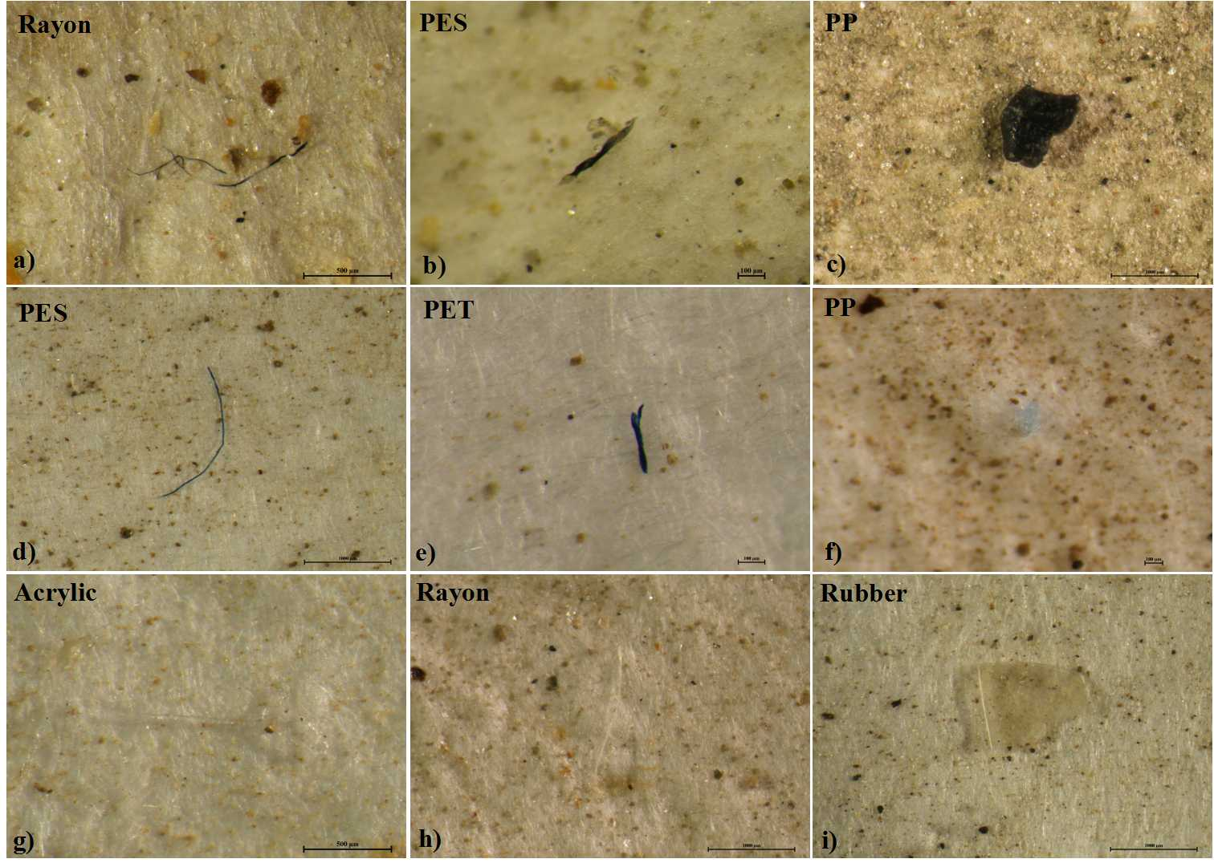
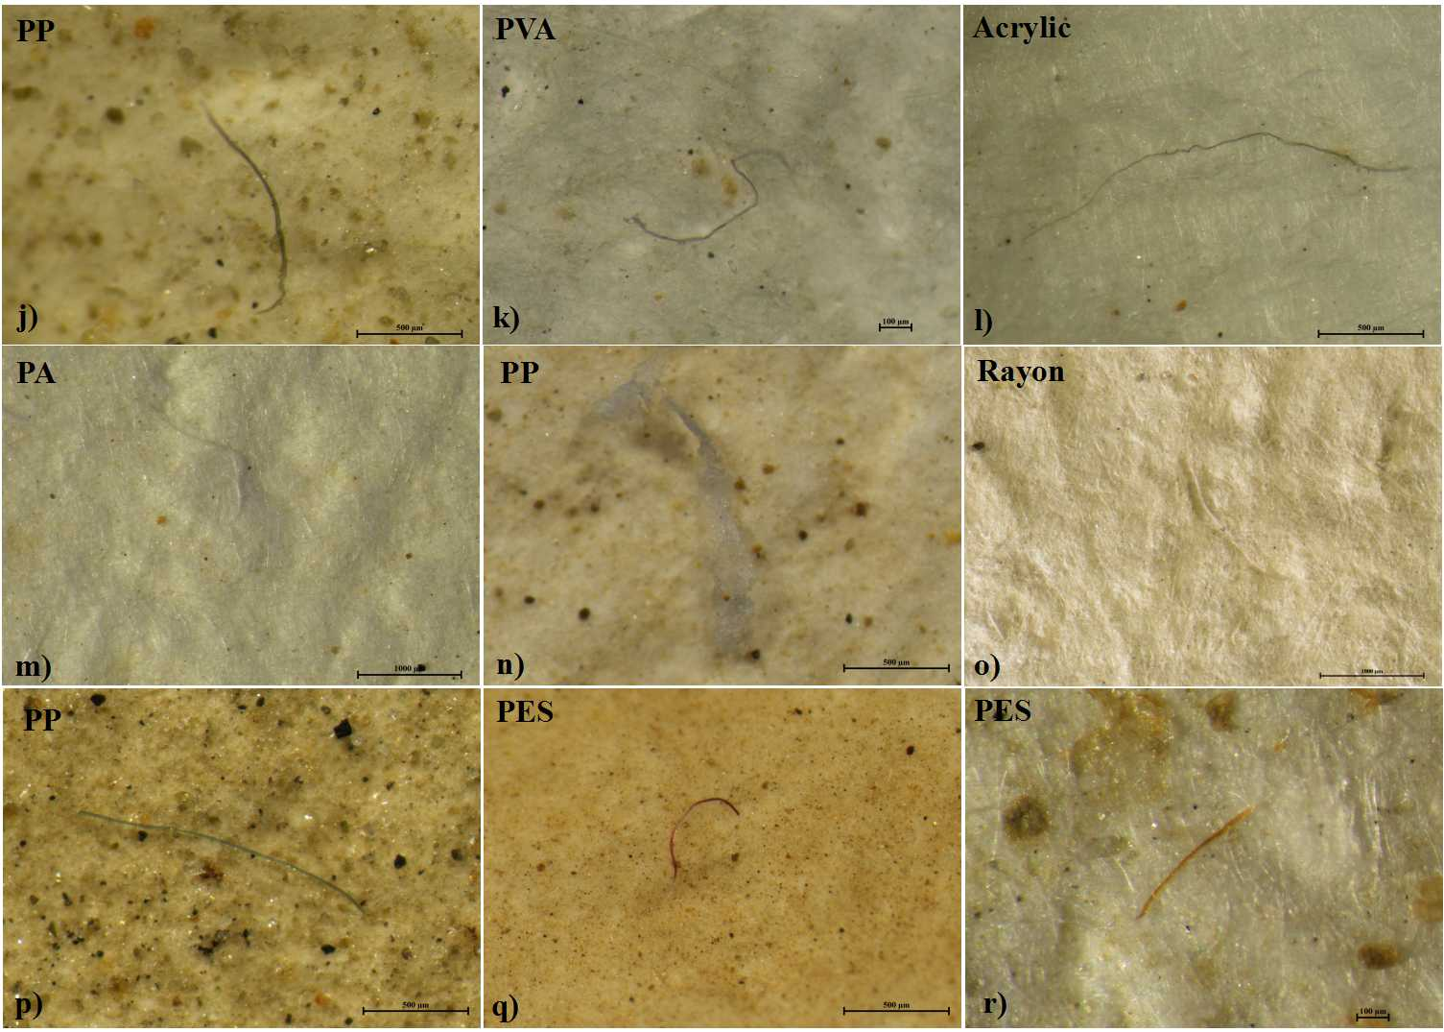
Fig. S1 Representative photographs of MPs with different types and colors in the sediments. (a) black rayon fiber; (b) black rayon PES; (c) black PP fragment; (d) blue PES fiber; (e) blue PET fiber; (f) blue PP fragment; (g) transparent acrylic fiber; (h) transparent rayon fiber; (i) transparent rubber fragment; (j) gray PP fiber; (k) gray PVA fiber; (l) gray acrylic fiber; (m) white PA fiber; (n) white PP film; (o) white rayon fiber; (p) green PP fiber; (q) red PES fiber; (r) brown PES fiber. PA: polyamide; PES: polyester; PET: polyethylene terephthalate; PP: polypropylene; PVA: polyvinyl alcohol.

Fig. S2 Infrared spectra of the representative MP polymers (red) and their reference spectra (blue) considered in this study. PA: polyamide; PES: polyester; PE: polyethylene; PP: polypropylene; PVA: polyvinyl alcohol; PVC: polyvinyl chloride; PET: polyethylene terephthalate; PAM: polyacrylamide; PB: polybutadiene; PC: polycarbonate; and PPS: polyphenylene sulfide.

